**Dual axis solar tracking system with weather condition**

**Abstract:**

Solar power is the fastest growing means of renewable energy. The project is designed and implemented using simple dual axis solar tracker system. In order to maximize energy generation from sun, it is necessary to introduce solar tracking systems into solar power systems. A dual-axis tracker can increase energy by tracking sun rays from switching solar panel in various directions. This solar panel can rotate in all directions. This dual axis solar tracker project can also be used to sense weather, and it will be displayed on LCD. This system is powered by Arduino, consists of servo motor, stepper motor, rain drop sensor, temperature and humidity sensor and LCD.

**Keywords:** Renewable, Solar panel, Arduino uno.

**Existing system:**

The methodology employed in this work includes the implementation of an Arduino based solar tracking system. Light Dependent Resistors (LDRs) are used to sense the intensity of sunlight and hence the PV solar panel is adjusted accordingly to track maximum energy.

**Drawbacks:**

* No monitoring of Weather condition

**Proposed system:**

This paper presents a Direct and indirect dual axis solar tracking system with weather condition. The components utilized here are Arduino uno, Solar panel, ldr’s, dc motor, l293d motor driver, servo motor, dht11 sensor, rain sensor, lcd display. Here the solar panel will shifts to direction of sunlight by using the ldr, where ldr increases its voltage as sunlight fall upon it and by utilizing dc motor it acquires the direction of sun. In this project there is continuous monitoring of weather condition i.e. temperature, humidity, rain sensor, and that output is displayed in lcd display.

**Block Diagram:**

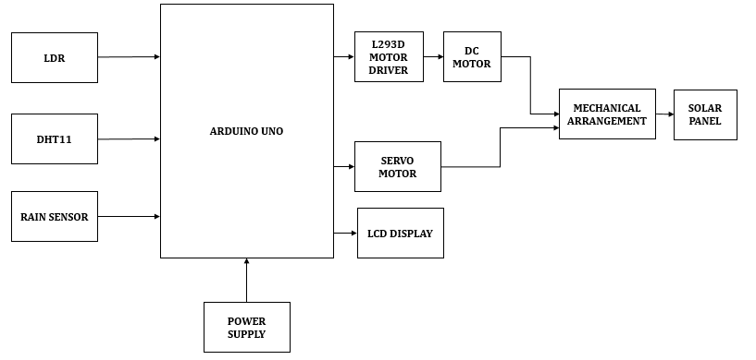

**Fig: Block diagram of dual axis solar tracking with weather condition**

**Advantages:**

* Solar trackers generate more electricity in roughly the same amount of space needed for fixed-tilt systems, making them ideal for optimizing land usage.
* Advancements in technology and reliability in electronics and mechanics have drastically reduced long-term maintenance concerns for tracking systems.
* Continuos monitoring of weather condition such as temperature, humidity, rainfall.

**Applications:**

* Domestic power source
* Solar power plant

**Hardware Requirements:**

* Power supply
* Arduino UNO
* L293D motor driver
* DC motor
* Servo motor
* Rain sensor
* DHT11
* Button

**Software Requirements:**

* Arduino IDE
* Embedded C

**Learning outcomes:**

* Arduino UNO Pin diagram and Architecture
* How to install arduino IDE software
* Setting up and installation procedures for Arduino UNO
* Introduction to Arduino IDE
* Commands in Arduino
* Basic coding in arduino
* Working of LDR sensor
* How to interface LDR sensor with Arduino?
* Working of rain sensor
* How to interface rain sensor with Arduino?
* Working of dht11 sensor
* How to interface dht11 sensor with Arduino?
* Working of L293D Motor driver
* How to interface L293D Motor driver and dc motor with arduino?
* How to interface servo motor with arduino?
* Working of 16x2 LCD
* How to interface 16x2 LCD with arduino?
* Practical exposure to:
* Hardware and software tools
* Solution providing for real time problems
* Working with team/ individual
* Work on creative ideas
* Project development Skills
* Problem analyzing skill
* Problem solving skill
* Creative and imaginary skills
* Programming skills
* Deployment
* Testing skills
* Debugging skills
* Project presentation skills
* Thesis writing skills